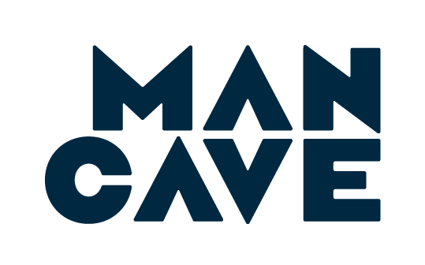

[insert date]

[insert name of person in charge]
[insert school name]
[insert school address]

Dear [insert name of person in charge],

I hope this [letter/email] finds you well. I am the parent of [insert your child’s name] in Year [insert your child’s year level].

I am writing because I recently learned about a preventative mental health organisation called The Man Cave and I thought that our boys at [insert school name] would greatly benefit from the program they offer.

The Man Cave works with young men, aged 12 to 18, and their communities to give them the skills to lead happier and healthier lives. The Man Cave’s programs foster healthy masculinity, positive mental health, respectful relationships and gender equality. They have worked with 15,000 young men since they began in 2014 and have received international recognition through support from The Royal Family and some of Australia’s most respected philanthropists and foundations.

I think we would both agree that the world our boys are growing up in is completely different to what it was five years ago. As a result, I feel we need to look at different ways to give our boys the necessary skills to grow and succeed. I believe The Man Cave is a great organisation to turn to for guidance on the matter.

This letter is a request to please consider the programs at The Man Cave for [insert who you’d like to program to be run for] at [insert school name]. Please contact them at their email hello@themancave.life and keep me informed as to how conversations progress.

Kind regards,

[insert your name]
[insert your contact details]

